Module-3

5 a) what is Map and Reduce ? Write a mapreduce program for weather forecasting.
- MapReduce works by breaking the processing into two phases: the map phase and the
reduce phase.
- Each phase has key-value pairs as input and output, the types of which may be chosen by the programmer.
- The programmer also specifies two functions: the map function and the reduce function.
- The input to our map phase is the raw NCDC data.
- We choose a text input format that gives us each line in the dataset as a text value. The key is the offset of the beginning of the line from the beginning of the file, but as we have no need for this, we ignore it.
Map Reduce:
- Our map function is simple.
- We pull out the year and the air temperature, since these are the only fields we are interested in.
- In this case, the map function is just a data preparation phase,
- Setting up the data in such a way that the reducer function can do its work on it: finding the maximum temperature for each year.
- The map function is also a good place to drop bad records: here we filter out temperatures that are missing, suspect, or erroneous.
consider the following sample lines of input data
(some unused columns have been dropped to fit the page, indicated by ellipses):
0067011990999991950051507004...9999999N9+00001+99999999999...
0043011990999991950051512004...9999999N9+00221+99999999999...
0043011990999991950051518004...9999999N9-00111+99999999999...
0043012650999991949032412004...0500001N9+01111+99999999999...
0043012650999991949032418004...0500001N9+00781+99999999999...
These lines are presented to the map function as the key-value pairs:
- The keys are the line offsets within the file, which we ignore in our map function.
- The map function merely extracts the year and the air temperature (indicated in bold text),and emits them as its output (the temperature values have been interpreted as integers):
(1950, 0)
(1950, 22)
(1950, −11)
(1949, 111)
(1949, 78)
- The output from the map function is processed by the MapReduce framework before
being sent to the reduce function.
- This processing sorts and groups the key-value pairs by key.
- So, continuing the example, our reduce function sees the following input:
(1949, [111, 78])
(1950, [0, 22, −11])
- Each year appears with a list of all its air temperature readings.
- All the reduce function has to do now is iterate through the list and pick up the maximum reading:
(1949, 111)
(1950, 22)
- This is the final output: the maximum global temperature recorded in each year.

The whole data flow is illustrated in Figure 2-1.

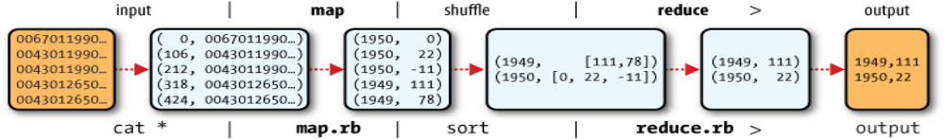
Example 2-3. Mapper for maximum temperature example
import java.io.IOException;
import org.apache.hadoop.io.IntWritable;
import org.apache.hadoop.io.LongWritable;
import org.apache.hadoop.io.Text;
import org.apache.hadoop.mapreduce.Mapper;
public class MaxTemperatureMapper
extends Mapper<LongWritable, Text, Text, IntWritable> {
private static final int MISSING = 9999;
@Override
public void map(LongWritable key, Text value, Context context)
throws IOException, InterruptedException {
String line = value.toString();
String year = line.substring(15, 19);
int airTemperature;
if (line.charAt(87) == '+') { // parseInt doesn't like leading plus signs
airTemperature = Integer.parseInt(line.substring(88, 92));
} else {
airTemperature = Integer.parseInt(line.substring(87, 92));
}
String quality = line.substring(92, 93);
if (airTemperature != MISSING && quality.matches("[01459]")) {
context.write(new Text(year), new IntWritable(airTemperature));
}
}
}

6. with the help of neat sketch,explain in detail about building blocks of HadoopThe building blocks of Hadoop. 12M
- Hadoop employs a master/slave architecture for both distributed storage and distributed computation. The distributed storage system is called the Hadoop Distributed File System (HDFS).
On a fully configured cluster, "running Hadoop" means running a set of daemons, or resident programs, on the different servers in you network. These daemons have specific roles; some exists only on one server, some exist across multiple servers. The daemons include:
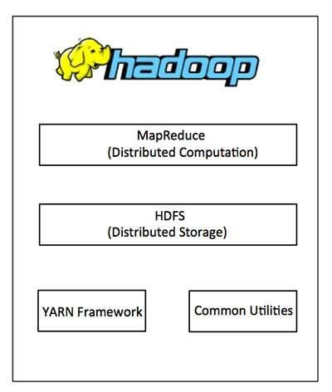
- NameNode
- DataNode
- Secondary NameNode
- JobTracker
- TaskTracker

HDFS Architecture:

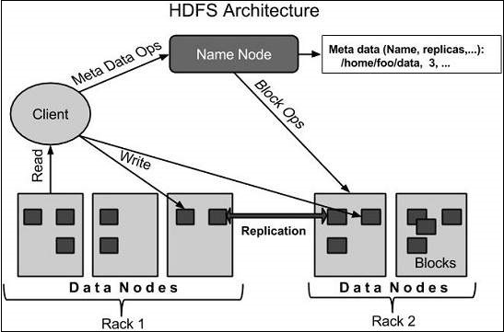
HDFS follows the master-slave architecture and it has the following elements.
Blocks:
- A disk has a block size, which is the minimum amount of data that it can read or write.
- Filesystems for a single disk build on this by dealing with data in blocks, which are an
integral multiple of the disk block size.
- Filesystem blocks are typically a few kilobytesin size, while disk blocks are normally 512 bytes. This is generally transparent to thefilesystem user who is simply reading or writing a file—of whatever length. However, there are tools to perform filesystem maintenance, such as df and fsck, that operate on
the filesystem block level.
- HDFS, too, has the concept of a block, but it is a much larger unit—64 MB by default.
- Like in a filesystem for a single disk, files in HDFS are broken into block-sized chunks,
which are stored as independent units.
- Unlike a filesystem for a single disk, a file in HDFS that is smaller than a single block does not occupy a full block’s worth of underlying storage. When unqualified, the term “block” in this book refers to a block in HDFS.
Namenodes and Datanodes
- An HDFS cluster has two types of node operating in a master-worker pattern: a namenode(the master) and a number of datanodes (workers).
- It is a software that can be run on commodity hardware
- The namenode manages the filesystem namespace. It maintains the filesystem tree and the metadata for all the files and directories in the tree. This information is stored persistently on the local disk in the form of two files: the namespace image and the edit log.
Datanodes:
- Datanodes are the workhorses of the filesystem. They store and retrieve blocks when they are told to (by clients or the namenode), and they report back to the namenode periodically with lists of blocks that they are storing.

Secondary NameNode(SNN): Secondary NameNode in hadoop is a specially dedicated node in HDFS cluster whose main function is to take checkpoints of the file system metadata present on namenode. It is not a backup namenode. It just checkpoints namenode's file system namespace
JobTracker and TaskTracker
- JobTracker and TaskTracker are 2 essential process involved in MapReduce execution in MRv1 (or Hadoop version 1). Both processes are now deprecated in MRv2 (or Hadoop version 2) and replaced by Resource Manager, Application Master and Node Manager Daemons.
Job Tracker –
- JobTracker process runs on a separate node and not usually on a DataNode.
- JobTracker is an essential Daemon for MapReduce execution in MRv1. It is replaced by ResourceManager/ApplicationMaster in MRv2.
- JobTracker receives the requests for MapReduce execution from the client.
TaskTracker –
- TaskTracker runs on DataNode. Mostly on all DataNodes.
- TaskTracker is replaced by Node Manager in MRv2.
- Mapper and Reducer tasks are executed on DataNodes administered by TaskTrackers.
- TaskTrackers will be assigned Mapper and Reducer tasks to execute by JobTracker.
- TaskTracker will be in constant communication with the JobTracker signalling the progress of the task in execution.

Module-4

7 ) Explain about Consumption of Analytics from Creation to Consumption
Let’s take a closer look at each of these stages:
- Communication: Successful consumption of analytics is a collaborative endeavor. The first step in this process is to take your analytics intent beyond your core team and sell it to a wider group of decision Makers.
- Implement: Organizations that successfully consume analytics are driven by leadership, which builds consensus in the organization and allows for moving ahead without the need to have everyone on board every step of the way.
- Measure: The true test of consumption is to use analytics to measure itself. However, the benefi ts need not always be translated in hard numbers.
- Align incentives: Successful consumption of analytics mandates creation of more structured decision-making processes, which is driven by data and analysis.
- Develop cognitive repairs: Our everyday decision making is influenced by numerous biases intrinsic to human nature. Presence of data and analysis challenges these biases and drives us out of our comfort zones. This results in undesirable confl icts and dysfunctional behaviors.
From Creation to Consumption:
- Various organizations in services as well as product-based industries have fl awlessly executed on creating analytics but have failed miserably on consumption. Creating analytics does not automatically result in institutionalizing analytics. Whether or not your organization suffers from this challenge will be determined by your answers to these key questions:
■ Do you have experience in creating a lot of analytics but failing at Consumption?
■ Does it make sense to ramp up/down analytics creation to maintain Balance with consumption?
■ Human bias exists. Do you need to develop structures that push people toward healthy conflict and resolution?
- If the answer to any of these questions is affirmative, then your organization suffers from the creation-consumption gap. To put it another way, it is the difference between doing analytics and being analytical. While doing analytics focuses on creating analytics, being analytical balances and integrates creation of analytics with consumption of analytics. Organizations able to bridge this creation-consumption gap will be able to capitalize on analytics as a source of competitive advantage.

8 a) Describe about Big Data Computational Limitations in detail. 8M
The typical Big Data computing platform limitations Encountered are:
■ Disk bound
■ I/O bound
■ Memory bound
■ CPU bound
- Disk bound means you simply don’t have enough storage capacity (e.g.,have 2 PB of data and there is only 500 TB of storage capacity).
- I/O bound is when there isn’t enough bandwidth to move around the data to meet the needs of the business. I/O Bound means the rate at which a process progresses is limited by the speed of the I/O subsystem. A task that processes data from disk, for example, counting the number of lines in a file is likely to be I/O bound.
- Computational platforms use a combination of memory and CPUs to process Big Data analytics. Memory is like the scrap of paper we use when doing a more complicated math problem. Most analytic software today attempts to load all the data needed for a calculation into memory and then uses the CPU to perform the calculation. This technique is very fast but is bounded by the available memory. Memory is limited on various computing platforms because memory is still fairly expensive. Here is the typical scenario when an analytic process become memory bound
- Similarly, some analytics are more computationally intensive, which means that they use more of the capacity of the CPU. An example of a mathematically intensive analytic is Monte Carlo simulation.
- CPU bound means the program is bottlenecked by the CPU, or central processing unit, while I/O bound means the program is bottlenecked by I/O, or input/output, such as reading or writing to disk, network, etc.

8 b) List the Characteristics of Big Data 4M
The Characteristics of Big Data are Volume, Velocity, Variety, Veracity, and Value.
1. Volume is a huge amount of data.
2. Velocity refers to the high speed of accumulation of data.
3. Variety: It refers to nature of data that is structured, semi-structured and unstructured data.
4. Veracity: it refers to inconsistencies and uncertainty in data
5. Value: The bulk of Data having no Value is of no good to the company, unless you turn it into something useful.

Module-5

9 a) Explain about Playing in a Global Sandbox 8M
- The previous section, companies that Operate globally have a lot of unexpected implications to consider, including and especially cultural ones.
- We might not consider how factors of daily human exchange play into such differences, such as lower-income environments in which entire families share a cell phone (not unlike the way people shared a single household landline).
- Their sense of privacy and where they draw boundaries is entirely different to situations where each family member has one or more personal mobile device. These are contextual factors—factors that affect perceptions of privacy. Whether global or local our contexts are constantly changing. Individuals
Personally Identifiable Information (PII): any  information that directly  or indirectly identifies a  person | Sensitive Information:  any information whose  unauthorized disclosure  could be embarrassing  or detrimental to the  individual | Other Information: any  other no identifiable  information about  an individual when  combined with PII
Name  Postal address  Email address  Telephone/mobile number  Social Security Number  Driver ’s license number  Bank/financial account  Credit or debit card number  ZIP Code | Race/ethnicity  Political opinions  Religious/philosophical beliefs  Trade union membership  Health/medical information  Marital status/sexual life  Age  Gender  Criminal record | Preferences  Cookie ID  Static IP address
Table 7.2 Types of Protected Information

9 b) Discuss about Privacy May Be the Wrong Focus can data be anonymized. 4M
- There are many examples of where the focus isn’t just about privacy; it ’s about what James Stogdill refers to as ethics and a positive customer relationship. For example, there probably isn’t a customer in the world that would be okay with an iPhone app that secretly downloaded your entire address book without your consent. That would classify as an intrusive tactic that would certainly irritate even the most liberal social butterflies.
- So as you can imagine with health care information, you want the doctor to be able to use the information to treat you. You want the doctor in an emergency situation to be able to call the hospital and say, “Hello, Andrew is on the way the ER. Here and the things you need to know about him.” So there are circumstances and exceptions for which companies would not need to notify or obtain the consent of the consumer about what is being done with their information.
- The same is true with sharing information with family members. In a situation where Andrew is unconscious, you would want my spouse to know, “Andrew is unconscious, here ’s his status …” So there are exceptions to the requirements to provide notice and obtain consent. In many other instances there is a need to use information, not for the exact purpose for which it was given, but to use it for ancillary Purposes.
- For example, in the health care industry and the pharmaceutical industry there’s a need to understand the adverse reactions to drugs. The pharmaceutical companies need to know someone had a reaction to penicillin because of the specific formulation of penicillin. In that case, query how do you do that without impacting the privacy of an individual? As a result of those concerns and those desires, there’s been a lot of discussion and a lot of work done to say, “Well many of the requirements of applicable privacy laws don’t apply to ‘anonymized’ data.”
Can Data Be Anonymized?
- The issue at hand is, can data gathered for a specific purpose then be used for other purposes (referred to as, “secondary use”) by somehow being stripped of the classification of personally identifiable information (PII) and allowing the individuals associated with that data to remain anonymous? Can this non-PII data be generalized for identifying collective patterns when there is no need to get back to an individual?
(OR)

10 a) Explain about The Privacy Landscape
In a personal one-on-one relationship, two parties mutually work out the details of an exchange and agreement. In the case of online (digital product/ service) agreements, the individual have only one immediate binary choice: accept the terms as stated or forego the service. There’s generally no negotiation or setting conditional exchanges. Then again, this is not much different than product agreements in the past.
Table 7.1 Privacy Landscape:
Businesses: Increased need to leverage personally identifiable and sensitive information for competitive advantage
- Significant investment in data sources and data analytics.
Criminals: Dramatic surge in identity theft.
- Sophisticated technology to exploit data security vulnerabilities
Consumers: Increased awareness and concern about collection, use, and disclosure of their personal information
Legislators: Responding to consumer concern by restricting access to and use of personal information.
- Significant impact and restriction for business

10 b) Explain about Conscientious and Conscious Responsibility 6M
- Contrary to what the news worthy incidents of privacy failures might suggest, most companies go through considerable effort to be conscientious about their approach to issues of privacy and attempt to avoid violation of individual rights. The issues are actually more aligned to that of consciousness—being aware of the potential consequences and taking steps to mitigate them … in advance, when possible.
- The reality is, as much as modern business attempts to do so, we can’t really control all that much. But we can influence results. As noted previously, the best way to manage issues of sensitivity is to simply allow individuals to control what “works for them” and to provide adequate (and accessible) feedback loops that are “active”—where real dialog is exchanged, where feedback is a critical, influencing factor for operational change, and where there is transparency in changes made.
- Even in the United Kingdom, their Data Protection Acts may specify such things such as “What is mean by sensitive personal data?” but then add a caveat at the end that says, “The Data Protection Acts require additional conditions to be met for the processing of such data to be legitimate. Usually this will be the consent of the person about whom the data relates.” For those companies that continue to take a parental posture in relationships—“We know what ’s best for you”—their failures will be heard and debated in the open courts of social exchange. Damage control will be difficult.

